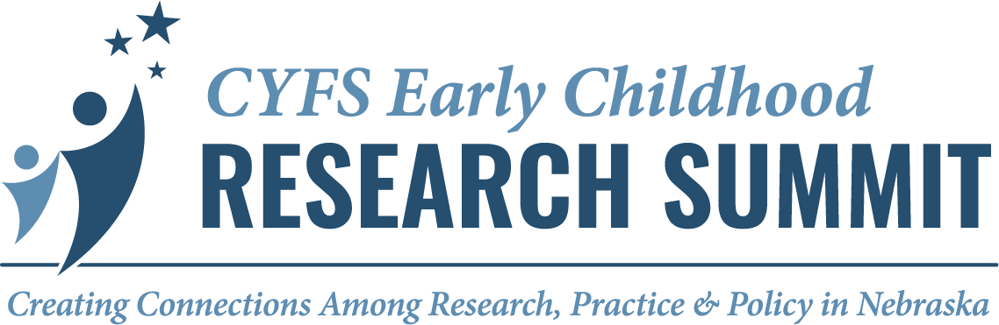
Facilitator Notes
The following notes were taken by facilitators and room hosts during the Summit concurrent sessions, and focus on next steps for research.

SESSION 1
A2 | Child Care Cost, Access, and Child Development: Kidsights Data 2025 Findings (Raikes, Owen, Bass, Johnson, Fritz)  - Longitudinal Data – data linkage, merging data  - Outside EC field
A3 | Fostering Educator Well-being and Relational Health through CHIME (Wilhite, Clark, Foged)  - Impact of relationship between educator self-compassion and self-efficacy
B1 | Advancing Professional Development to Promote Teachers and Parents as Partners (Witte, Sheridan, Wheeler, Nelsen, Brunke)  - Connections to childcare – resources, supports, access, family engagement  - Factors contributing to challenges  - Early intervention and prevention
B2 | Practices to Support Children Involved with the Child Welfare System (Davis, Poudel)  - Practices for children in welfare adoption competency  - “Light” version for ECE providers  - Impacts of turnover and on turnover/retention  - Hear from ECE providers on applicability of the training – language and culture
B3 | Preschool Science Talk in Action and Reflection (PreSTAR) Rural Nebraska (Hong, Poppe, Werth)  - Differences for preservice teachers in hearing/learning about reflective practice and seeing/doing it in action  - Collaboration with scientists and making science learning accessible to young children  - Focus on rural context – what do children see?

SESSION 2
A1 | Using Collaborative Inquiry to Guide Early Childhood Teachers’ Professional Development (Gabas, Wernick, Rittenburg, Napoli)  - Infant/toddler teachers and preschool teachers together for PD – efficacy?  - How do you elicit the process of inquiry-based practices in teachers? (reflections)  - How can we encourage/facilitate teachers to become the owners of learning?  - How do we support teachers so that they can become better observers of children’s play and learning?  - And recognize them as “data”
A2 | Heat at Play: Thermal Portraits of Children’s Everyday Environments (Lindquist, Karle, Schutte)  - How does heat impact the child?  - Engaged play  - Physical activity  - Behavior after outdoor play
B3 | Engaging Diverse Communities to Inform Early Childhood Teacher Preparation (Torquati, Spies, Rajesekar, Kazemi, Yunes-Koch)  - Curious when bringing back the findings to the communities who participated – what are their reactions to the implications  - What will define success for RESPECT?

SESSION 3
A1 | Beyond Perception: How Accurate are Self Reports in Coaching? (Knoche, Schachter, Li, Yoon, Bainter)  - What was used to analyze qualitative data?  - What template was used for coaching log?  - Form of documentation may matter for giving information on what’s happening in coaching session  - Characteristics of coaches with highest match  - Content of coaching and coach content of knowledge  - Explore the relationships of coaches and coachees  - Coaching school leaders (i.e., admin)  - Alignment of coaching practices and what coachees did after session
A2 | Nebraska’s Early Childhood Workforce: The Leaky Bucket Problem (Jeffries)  - CDA representation in data  - Entrants into field – where they come from  - Tracking for non-insurance  - Children not in school-based preK (e.g., Head Start)  - Need for legislation to require involvement in other data systems  - Problem of need underrepresented because of lack of access to more complete data  - Brief for policymakers  - Risk of cutting federal financial aid  - Supply-demand, why are wages not increasing?  - ECIDS – link to database  - Cost analysis – cost to state economy  - Inflow or outflow – what is biggest part of the problem?  - Frame problem in ways other industries understand (e.g., cost of lack of retention)
B2 | Cultural Engagement and Educational Outcomes Among American Indian/Alaska Native Children in Head Start (Prokasky, Encinger, Kang, LaPointe)  - Cultural validity of social skills – how would you assess it in culturally valid ways? When the communication culture is extremely diverse as well?  - How can we engage the communities in this kind of work from the get go?  - Be cautious about how results are interpreted because findings tend to be quite mixed (especially for health outcomes)  - It’s hard to capture culture using current measures and protocols. There are so many layers in understanding the nuance of culture and cultural practices/engagement
B3 | SUNRISE Nebraska: Preschool Movement Behaviors in a Global Context (Rech, Dinkel, Kai)  - Parent screen time – how does this influence or affect?

SESSION 4
A1 | Iterative Development of an Interactive, Family-Inclusive, Socio-Emotional Assessment System for Preschool-Aged Children (Clark, Finch, Hong, Torquati, Leeper-Miller, Lyu, Prokasky)  Connect. Feel. Belong. Igniting Statewide Social and Emotional Development Conversations (Yan, Griffin)  - Rural areas  - Collaboration with like-minded partners  - Connect to public policy by increasing awareness and support
A2 | Burnout in Early Childhood Education: Relationships with Age, Role, and Experience (Daro, Thompson, Sutton)  - Impacts of work vs life on mental health  - Restructure understanding of the impacts of compensation on burnout  - What is impacting mental health and how does leaving EC work impact it?  - What is mental health? What contributes?  - How do results differ by setting? (in home, school based, etc)  - What supports do in home providers need, without feeling guilt?
B1 | Impact of Write Sounds on Transcription and Word-Level Skills (Bazis)  - Letter-sound instruction vs letter production instruction – separate or taught together
B3 | Play-Based Learning Across the Ages: Expanding the Role of Play in Education (O’Shea)  - Look at nature-based outdoor play  - Play in educational leadership  - Who is doing play-based pedagogy in high school settings  - Play and how to use in things like “math anxiety” and science games, etc.  - Play limitations with rising tech

